MANUFACTURING SKILLS To apply, call OAI:

JOB TRAINING PROGRAM (708) 283-5020

Now Enrolling!
KEY ADVANTAGES:
- State-of-the-art training & facilities
- Industry-recognized certifications (MSSC and NIMS)
- Part-time and full-time schedules
- Assistance in job placement
- Grant-funded financial assistance

PROGRAM REQUIREMENTS:
- Be unemployed or underemployed
- Be at least 18 years old
- Be interested in a career in manufacturing
- Be physically fit to do the work
- Have a state ID or driver’s license
- Be drug-free

3 CONVENIENT LOCATIONS:
- Daley College
7500 S. Pulaski Rd. Chicago, IL 60652 • Prairie State College
202 S. Halsted St.
Chicago Heights, IL 60411
- South Suburban College
16333 S. Kilbourn Ave.
Oak Forest, IL 60445

NEED A JOB?
A Special Presentation for Blue Island Residents!
Tuesday, January 13th @ 10:00 a.m.
City Hall East Annex, 2434 Vermont St, Blue Island
The CGMP job training program is designed to help you acquire quickly the skills and credentials manufacturing companies are looking for in the following careers:
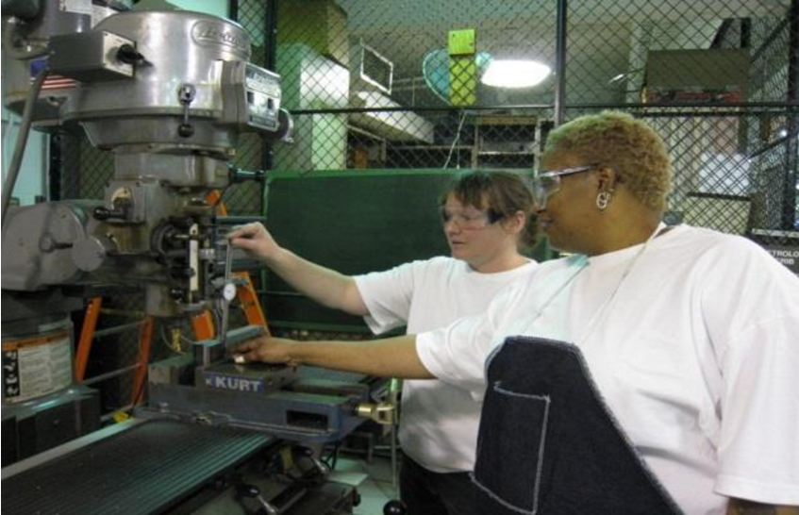
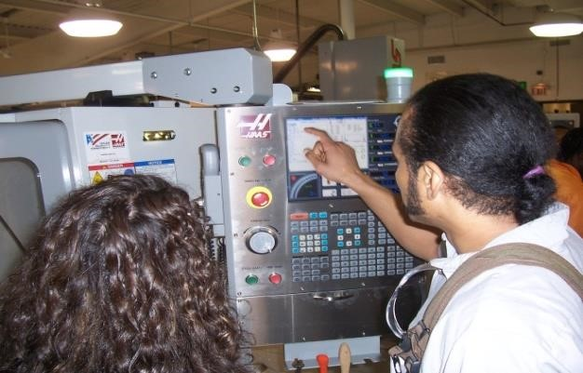
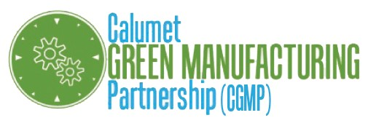
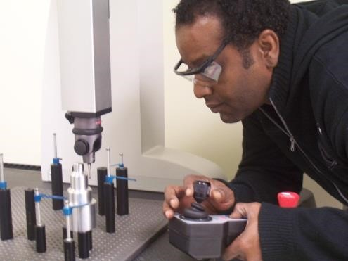
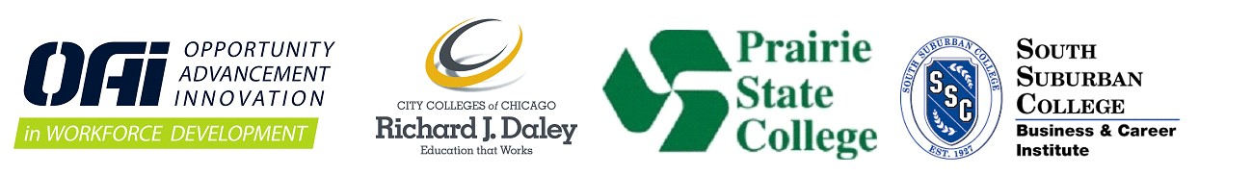
Punch press operator, manual machine operator, production technician for molding and casting, CNC operator trainee, quality assurance inspector, CNC machine operator, CNC machinist, CNC programmer trainee, quality assurance technician, factory automation technician, and CNC programmer.

Why learn the skills for a career in manufacturing technology?

HIGH DEMAND
The Association for Manufacturing Technology’s vice president said in May 2012 that: “There’s not enough skilled labor to make things go. Orders will stay strong because technology is the only way around the 300,000 unfilled openings for skilled machinists.”
Source: AMT, www.amtdwg.org, May 2012.

WELL PAYING JOBS (with benefits!)
Certifications earned through CGMP can lead to:
- Basic in Quality Assurance: $12-$14*/h
- Basic CNC Machining/Factory Automation: $13-$17*/h
- Advanced CNC Machining/Factory Automation: $15-$21*/h
- AAS** in Manufacturing Technology: $60,000*/year

Learn manufacturing on either a part-time or full-time schedule.
Applicants qualify based on reading & math assessment testing.
To apply, contact OAI:
(708) 285-5020

This $1.3 million project receives 65% ($850,000) of its funding from the US Department of Labor Green Jobs Innovation Fund.

