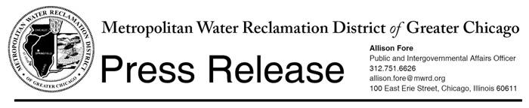

For immediate release

February 25, 2014

**MWRD to add 4th collection site to bi-annual unwanted medicine collection**

To prevent or reduce accidental contamination of streams, rivers and lakes, the Metropolitan Water Reclamation District of Greater Chicago (MWRD) is joining the U.S. Drug Enforcement Administration's (U.S. DEA’s) national unwanted medicine “Take-Back” initiative on Saturday, **April 26,** from **10 a.m. to 2 p.m.** to collect unwanted medicine at four MWRD facilities:

* Stickney Water Reclamation Plant, 6001 W. Pershing Road, Cicero;
* O’Brien Water Reclamation Plant (formerly North Side), 3500 Howard Street, Skokie
* Calumet Water Reclamation Plant, 400 East 130th Street, Chicago; and,
* Egan Water Reclamation Plant, 550 S. Meacham Rd, Schaumburg, IL.

The MWRD has participated in all of the U.S. DEA’s nationally-organized prescription drug take back day programs and removed hundreds of pounds of medicines from the waste stream. To accommodate residents in the northwestern portion of the Cook County, the Egan WRP will serve as a collection site.

The MWRD’s wastewater treatment facilities are not designed to remove pharmaceutical products if they are poured down a drain or flushed down a toilet. The chemicals can work their way into lakes or streams, so this special collection gives the community an environmentally-friendly opportunity to properly dispose of expired or unwanted medications.

Additional information about the bi-annual pharmaceutical disposal collection can be found at <http://www.deadiversion.usdoj.gov/drug_disposal/takeback/>.

**Our water environment: Take it personally!**